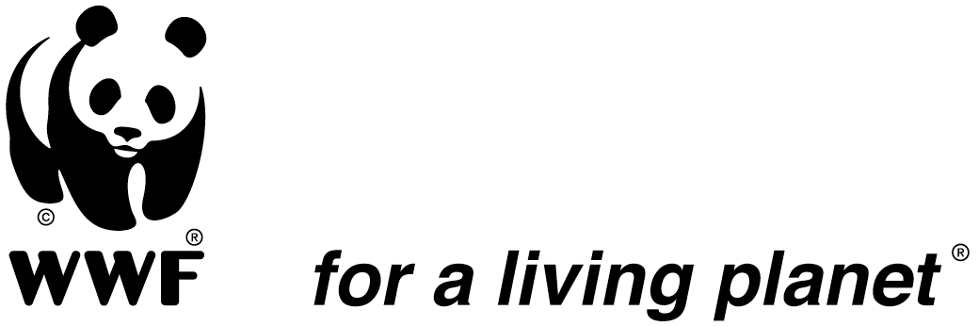

JOB DESCRIPTION

Position Title: Community Based Wildlife Management Lead
Reports to: Conservation Manager
Duty Station: WWF Tunduru, with regular Travels to Dar Es Salaam
Supervises: Technically supervises CBNRM Ruvuma Landscape Staff
Effective Date: 1st January 2019

- INTRODUCTION
WWF Tanzania Country Office (WWF TCO) is implementing its Country Strategic Plan (CSP) for 2015 to 2020. The goal of the strategic plan is to ensure that by 2030, Tanzania’s outstanding and globally significant natural wealth and biodiversity are sustained and support equitable and gender-sensitive local livelihoods and national economic development for present and future generations. The Ruvuma Landscape as defined under the strategy is a focal landscape that encompasses a socio-ecological system that includes Mikumi and Udzungwa Mountains National Parks, the Selous Game Reserve, a number of Game Controlled Areas and at least 10 Wildlife Management Areas straddling the Ruvuma River and the border areas of Mozambique. Programmatically the Ruvuma Landscape entails working with a variety of stakeholders, landowners and key partners including local communities, national and local Government Agencies, NGOs and the private sector on both sides of the border to create a cohesive transboundary area conserving the connectivity of the miombo ecosystem and its sustained provision of valuable goods and services. This also includes supporting the implementation of community-based natural resources related activities within Selous Game Reserve, the Wildlife Management Areas and the Selous-Niassa Wildlife Corridor to secure them for the future generation.
Under the CSP 2015-2020, the Ruvuma Landscape Programme goal is to ensure “By 2020 the ecological integrity of Selous-Ruvuma landscape is maintained and contributing to improved livelihoods; with populations of selected wildlife species, and coverage and condition of designated forests, at least above 2015 levels”. While under the Elephant Programme the goal is “By 2020, elephant population in Selous-Ruvuma landscape is increased by 7.5% of 2015 levels”. The major threats to be addressed include elephant poaching and illegal trade and utilization of wildlife resources, wildlife crime, the degradation, fragmentation and encroachment of wildlife and forest habitats, and incidence of human-wildlife conflicts, lack of and inadequate benefits to local communities within the landscape among other threats.
- MAIN ROLE/ PURPOSE
The main role of the position is to provide technical support to community based initiatives in wildlife management areas (WMA) approach and also be the focal point for engagement with stakeholders, implementing partners and government agencies in promoting participation of stakeholders in the implementation of WMA monitoring tools such as the Management oriented monitoring system (MOMS) etc. Being the Community Based Wildlife Management Lead, the role will also be providing technical assistance in the implementation of the Wildlife Practice Strategy Country wide and represent TCO in Wildlife Practice activities and programs.
- SPECIFIC TECHNICAL ROLES

- In specialized technical areas in CBNRM and general management planning for WMAs identification of needs for short-term technical assistance, to the program team and partners, particularly with regard to participatory natural resources management, land use planning, general management plans and business plans as well the promotion of sustainable, conservation business enterprises as well as support the new species program in planning and implementing the CBNRM approach through the WMA process;
- Develop and / or strengthen monitoring plans, systems and processes for systematically collecting, documenting, storing, reviewing and using quantitative and qualitative by disaggregation and analysis of data (by gender, age, poverty, etc.) and identifying opportunities to asses and/or evidence the empowerment of women and girls information for reporting and building the capacity of partners and AAs on WMA Monitoring System;
- Oversight of Village Game Scouts (VGS) Training at Likuyu-Sekamaganga and other Community Based Conservation Training Center in Tanzania
- Facilitate the adoption and use of technology including use of unmanned air vehicles (UAVs) in law enforcement in Ruvuma Landscape through training and building capacity of the different stakeholders with mandate in protected areas management;
- Facilitate the development, and use of MEL frameworks for two programs in order to deliver evidence of improvements in quality of program management and review and strengthen chains of evidence & the quality of data and evidence particularly that which supports reporting at the program outcome and impact level;
- Facilitating the development and implementation of the necessary management agreements, Grants, plans and arrangements for successful projects implementation;
- Principal technical oversight of the Pachyderms Project, SECAD and Input to Global Campaign of “Our Shared Heritage Site” focusing on Selous to ensure work plans and implementation systems and processes are in place that would lead to systematically collecting, documenting, storing data are in place and adhered for production of quality reports;
- Oversight of reporting to ensure the delivery of good quality six monthly / annual Technical Programme Reports (TPRs) and other reporting as per donor requirements;
- Project Proposal development and fund raising;
- Performing other duties as directed by Conservation Manager and Country Director.

- OTHER DUTIES INCLUDE:
- Production of work plans, budget and Annual Activity Plans for SECAD, PACHYDERMS and related Ruvuma Landscape projects.
- Production of Technical Progress Reports (TPRs) for SECAD, Pachyderms and related Ruvuma Landscape projects.
- Technical Contribution to Selous Campaign.
- Project Proposals to donors
- Functional and operational Monitoring System Status report in key WMAs offering learning opportunities.
- Training on Technical and Financial Reporting for VGS and WMAs
- Coordinate the use of Technology Report on regular basis in natural resources management
- Liaison between WWF and Wildlife Management Institutions and Government Authorities

- REQUIRED QUALIFICATIONS AND SKILLS
- Post Graduate University degree in Natural Resources Management and Assessment with relevance to Environment Management, Forestry, Climate Change, Wildlife, Marine or Social Sciences or related area but a masters will be an added advantage;
- Five (5) years minimum of field and management working experience in one or (ideally more than one) of Miombo ecosystem management, protected/conservation area management, CBNRM, forest and wildlife management and other relevant fields in the region
- Excellent management and co-ordination skills, with experience in technical programme implementation and reporting and adaptive programme management through management orientated monitoring systems;
- Excellent interpersonal, facilitation, communication and leadership skills and ability to operate as part of the team;
- Experience in project/programme planning, management and reporting .
- Clearly demonstrated experience in field capabilities and leadership of field staff and willingness to participate in field activities, surveys and travel to remote areas within the landscape.
- Excellent knowledge and use of English and Swahili language;
- Ability to meet deadlines and accuracy and attention to detail.

- BEHAVIOURAL COMPETENCIES
- Adheres to WWF’s values, which are: Passionate & Optimistic, Challenging & Inspiring, Credible & Accountable, and Persevering & Delivering Results.
- Demonstrates potential in the following critical competencies:
  - Change Leadership - Continuously seeking (or encouraging others to seek) opportunities for different and innovative approaches to addressing organizational problems and opportunities
  - Drive for Results - Setting high goals for personal and group accomplishment; using measurement methods to monitor progress towards goal attainment; tenaciously working to meet or exceed those goals while deriving satisfaction from the process of goal achievement and continuous improvement
  - Decision-making - Identifying and understanding issues, problems and opportunities; comparing data from different sources to draw conclusions; using effective approaches for choosing a course of action or developing appropriate solutions; taking action that is consistent with available facts, constraints and probable consequences

- WORKING RELATIONSHIPS

Internal - Works and liaises closely with the WWF TCO Programme Coordinators and other staff in WWF offices outside the region.
External - Works closely with relevant stakeholders, implementing and donor partners (bilateral and multilaterals in the area). Engage in Global Wildlife Practice strategy implementation

