WWF Project/ Programme Plan (Proposal) Template[1]

**Version:** June 2020

**Purpose and Audience**:

This template should be used to present clear and compelling information on the context and design for a mid-large (over €100K p.a.) project, programme or initiative[2]. It should capture the **planned work** of the project team and partners (and thus guide implementation), support **quality review** and approval (see [here](https://wwforguk-my.sharepoint.com/personal/wbeale_wwf_org_uk/Documents/1.%20WWF/1.1%20NETWORK%20STANDARDS%20DEVELOPMENT/2.%20Project%20&%20Initiative%20Management/Proposal%20Template/to%20be%20added)), and as necessary enable **resources and funding** to be allocated or obtained from donors.

All submissions for funding to WWF donor offices should use this template, unless an alternative template is required by a primary donor (such as a PSP). Note that donors (both internal and external) typically assess plans according to criteria such as: relevance of the project, transformational potential, feasibility, sustainability, risk management, and sound M&E. Well-written responses to each section of the template will help a proposal to be seen as responding well to these criteria**.**

**General Principles:**

* **Support a consistent approach.**  Use this template for all mid-large projects > €100K p.a. In general teams should develop an initial plan using the Concept template, and then a more detailed plan using this ‘Proposal’ template. *(N.B. For smaller projects (< €100K p.a.), a Concept plus workplan and budget are sufficient for a project plan – this Proposal template is not required).*
* **…but adapt as necessary.** The WWF Network Standards encourage a tailored approach according to the situation. In this spirit, project teams and reviewers should apply their own judgement when considering the level of analysis and detail needed in a project plan. (For guidance see [here](http://tbc)).
* **Engage stakeholders** (see guidance [here](https://drive.google.com/drive/folders/1nGoHbsT5XilB3kuNXsgzMWMBEIYawBaA?ths=true.)). Project development should be participatory in nature and use forms of engagement appropriate to the context. It may be very important to include rights holders[3] and potential partners, depending on the situation.
* **Reference, and learn from other relevant work.** In particular, where place-based work is planned, refer to the existing land/seascape plans to align strategies and to the associated safeguard mitigation plans[4]. If project activities are aligned with what is already safeguarded, ensure that these activities include the associated mitigation action. If the project includes new activities not covered by what is already safeguarded, then those activities will need to be safeguarded (assessed, and if necessary, mitigated). Note any mitigation steps at appropriate stages in planning documents, including in section 4 of this template.

**Other Guidance:**

* **Target length**: Aim for 15-30 pages, including supporting figures and graphics, plus annexes.

(Before you finalise the document, be sure to delete the blue guidance text in this template).

* **Further Guidance…**is referenced through this document and is available on the [Network Standards site](https://sites.google.com/wwf.panda.org/networkstandards/policy-areas/project-and-initiative-management/2-1-overview-of-essentials). To provide feedback on this template please contact Will Beale [wbeale@wwf.org.uk](mailto:wbeale@wwf.org.uk)
* **Seek input and support**…fromappropriate expertise such as Practice teams, quality management process management experts, communications specialists/ editors etc.
* **Share the project plan with key audiences.** This includes uploading the plan to the [Insight CPM database](https://insight.panda.org/Landing/Landing). Take care to avoid sharing any confidential information, such as data that is protected by regulation (such as personal data), or which is restricted by a confidentiality clause in a contract. See [here](https://sites.google.com/wwf.panda.org/networkstandards/policy-areas/information-and-communication-technologies) for WWF-Int guidance on sharing confidential information.
* **Terminology.** This template is designed to be consistent with [WWF Network Standards](https://sites.google.com/wwf.panda.org/networkstandards/policy-areas/project-and-initiative-management/2-1-overview-of-essentials). For definitions of key terms, see WWF Standard Terminology [here](https://wwforguk-my.sharepoint.com/personal/wbeale_wwf_org_uk/Documents/1.%20WWF/1.1%20NETWORK%20STANDARDS%20DEVELOPMENT/2.%20Project%20&%20Initiative%20Management/Proposal%20Template/to%20be%20added).
* **Software.** If the team wishes to use project management software, Miradi is recommended (see [here](https://sites.google.com/a/wwf.panda.org/ppms/step0) for download instructions).

**Project Information at a glance**

|  |  |
| --- | --- |
| **Name of Project** | Aim to give a clear, concise expression of the project |
| **Date, Version** |  |
| **Location:** | Specify the region, country, ecoregion or landscape (use the landscape database to select all landscapes/ seascapes that have a strong and direct relationship with the work to be carried out). |
| **Link to WWFs and other relevant Global/ National Priorities** | Briefly describe the project’s most direct contributions to: WWFs global priorities (Global Goals, Outcomes and [Targets of the Practices](https://sites.google.com/wwf.panda.org/critical-contributions/guidance-per-practice) and/or other Initiatives), your office’s strategic direction, and any key external agendas |
| **Author(s)** | Name and email address, department and organisation  And other contributors as appropriate. (For people outside WWF, do not include any personal information such as email address). |
| **Implementing Office(s)/ Partners** | Name of each office/ entity and point of contact - name and email.  Where more than one WWF Office will implement the work, clarify their roles e.g. which office will take the lead role in planning, coordination and reporting. |
| **Project Duration** | Approx start and end date |
| **Budget** | **Total anticipated expenditure:** (over the project duration)  **Secured budget:** (state the amount secured so far and its sources)  **Requested budget:** (for a proposal to a donor, state the amount requested) |

## Executive Summary (1-2 pages)

Hint: Always write this section at the end of the project development process rather than the beginning

The Executive Summary should support internal and external communications. Remember that the main audiences for this summary are likely to be decision makers, potential funders, fundraisers and communicators; if they were to read only this section, they should understand the essence of the project and be convinced of its importance.

In general the executive summary should:

1. Introduce the project - include a high-level description of what the project will aim to achieve and how it will do so (the theory of change).
2. Describe the main points from each section of the document that your audience should know.
3. End with a conclusion - Outline the 3-5 main messages that you want the audience to note.

## Table of Contents

Executive Summary (1-2 pages) 1

Table of Contents 2

List of Abbreviations 2

1. RELEVANCE 3

2. SCOPE AND CONTEXT 3

3. GOALS/ OBJECTIVES, STRATEGIES & THEORY OF CHANGE 4

4. RISKS, SAFEGUARDS AND SUSTAINABILITY 4

5. MONITORING, EVALUATIONAND LEARNING 5

6. ROLES, CAPACITY AND GOVERNANCE 6

7. BUDGET AND FUNDRAISING 6

ANNEXES 6

Annex 1 Current Situation and Theory of Change (supporting sections 2 and 3) 7

Annex 2 Stakeholder/ rights holders engagement plan 8

Annex 3 Risk Management 9

Annex 4 Monitoring Plan 10

Annex 5 Workplan and Budget 12

Annex 6 Organisational/ Governance Structure (WWF and Partners) 13

References and Bibliography 13

Sign Off (see Approval form) 13

## List of Abbreviations

Please provide a list of any abbreviations or acronyms that are used in this document.

## 1. RELEVANCE

(1-2 pages)

Summarise the project’s relevance to key stakeholders and how it relates to other initiatives or to opportunities that may be leveraged. In particular:

* How is the project relevant to **internal and external agendas** i.e. WWF Global Priorities ([Practice Outcomes, Targets](https://sites.google.com/wwf.panda.org/critical-contributions/guidance-per-practice) and Initiatives), office strategies, SDGs, national and regional priorities?
* How is the project **relevant to key stakeholders** and, where appropriate, rights-holders, and how have these people been engaged in the design of the project? (This may require application of the Environmental and Social Safeguard Framework).
* How does the project relate to **other efforts or previous work**, and how does it add value?If the project is part of an overall programme that has already been approved, make this clear.
* Why should **WWF and its partners** carry out the project (rather than another organisation)?

## 2. SCOPE AND CONTEXT

(2-8 pages)

This section should describe the project’s **scope** and **context**[5]/ situation and should support the case for WWF’s engagement. The writer should provide or reference relevant **evidence** (scientific evidence and/or insights gained through participatory or prioritisation processes) to support the statements made. Inclusion of a **situation diagram** (or similar visual) in Annex 1 is recommended to provide an overview of the situation and the relationship between factors. Key points to cover include:

* **Scope (**or boundary) of the project - geographic and/or thematic – and your justification for this choice. For example, consider the biological or environmental significance and/or social, political, land use and economic context. If relevant, provide a map and note key project sites.
* **Focus**– those elements which the project is intended to affect - and their current and desired status. For place-based projects, this typically relates to biodiversity and/ or human wellbeing (and is termed “targets” in the Conservation Standards).
* **Pressures[6], Drivers[7] and Opportunities -** the main factors that directly or indirectly affect the project’s scope and focus. Where relevant, factors should be rated according to appropriate criteria so that the priority issues to be addressed are clear (see, for example, [Direct Threat rating](https://wwforguk-my.sharepoint.com/personal/wbeale_wwf_org_uk/Documents/1.%20WWF/1.1%20NETWORK%20STANDARDS%20DEVELOPMENT/2.%20Project%20&%20Initiative%20Management/Proposal%20Template/to%20be%20added)). Drivers that affect the situation may provide opportunities that can be exploited (e.g. institutional, social, political, economic, demographic factors). Include climate vulnerabilities where relevant.
* **Actors/ stakeholders.** In relation to the factors identified above, describe the main people potentially affected by the project, who could affect the project, and the influence they have. This may be shown as a Stakeholder Analysis grid (see Annex 2), and could identify people such as: 1) disruptors to be influenced, 2) general interest groups to be informed, 3) those in power to be consulted, 4) those deeply engaged who you want to participate/ collaborate, 5) people with statutory rights who must give consent, 6) future ownership to be empowered etc.[8]

## 3. GOALS/ OBJECTIVES, STRATEGIES & THEORY OF CHANGE

(2-8 pages plus monitoring table)

This section should describe what the project will **aim to achieve and how**, and should be related to the main points noted in the scope and context above. Please summarise the **goals/ objectives**, the main **strategies** and why you have selected them, the **theory of change** and any key **assumptions.** Details should be provided in Annexes 1 and 2. Key elements to include are:

* **Goals** and **Objectives**[9] which should be SMART *(specific, measurable, achievable, results-oriented and time limited)*. As examples, these may relate to changes in biodiversity, outcomes for rights holders/ communities, behaviour changes of key audiences, reduction in pressures etc.
* **Strategies[10]** (and/ or Activities and Outputs if appropriate)[11]**.** The strategies and activities selected should be the most effective and efficient. Highlight whether your strategy/ strategies are designed to address a single critical issue or several related factors.
* **Theory of Change[12]** and the evidence base associated with it. The theory of change should briefly describe the logic of how your strategies will deliver short-medium term objectives that will ultimately lead to the achievement of goals. Results chains (or a similar visual) are recommended as a supporting tool. Highlight any key assumptions that need to be met for the project to succeed; this may include comments on the technical and economic feasibility of the project.
* **Partners and Rights Holders.** Describe the ownership/buy-in of relevant rights holders to the above strategies and theory of change. List the partners that are key to successful implementation and summarise their track record/ capacity; clarify which partners are already engaged and which you still need to get on board. Details of the stakeholder engagement plan may be shown in Annex 2 (mandatory for place-based projects).

## 4. RISKS, SAFEGUARDS AND SUSTAINABILITY

(1-4 pages)

This section should a) highlight any key risks and safeguards issues and mitigation, and b) explain how the project’s desired impacts can be extended and sustained. This may inform your strategic approach and theory of change, as well as your workplans. Note that actions defined to help manage risks and safeguards may support the sustainability of project results; meanwhile designing without sustainability in mind presents risks to achievements. Key elements to cover include:

* **Risks.** Identify the main risks (e.g. social, political, economic, institutional) that may affect the achievement of project objectives and state how do you plan to mitigate them; give details in Annex 3 and summarise the top 5 key risks using the table below. For guidance, see [here](https://docs.google.com/document/d/17mGc-SHmx4F5bJiaAMHo4ov-fokccEfm1dtEBJWyLu0/edit#heading=h.w7ls9tlfobqa). In addition, you may highlight circumstances where uncertainty could lead to opportunities.

|  |  |  |  |
| --- | --- | --- | --- |
| Risk description (risk event, causes and effect) | Risk Rating (High, Medium, Low) | Mitigation actions | Residual Risk Rating (High, Medium, Low) |
|  |  |  |  |

* **Safeguards.** For place-based projects, provide links to each relevant landscape/ seascape safeguards mitigation plan. (See the environmental and social safeguards and WWF social policies)[13]. Indicate how this project has incorporated relevant elements of the mitigation plans, and if necessary define any additional mitigation actions. In the case where there is no existing landscape mitigation plan, define a process and timeline for safeguarding the project.
* **Longer-term thinking, Sustainability and Exit Strategy[14].** Outline how WWF might ultimately exit or transition from the project, and key considerations/ conditions for sustainability. Where relevant, share ideas on potential mainstreaming and scaling up of the project’s strategic approach. Mention any future phases that might be needed beyond the initial/ current phase.

## 5. MONITORING, EVALUATIONAND LEARNING

(1-3 pages)

This section should describe how you will measure and analyse the project’s success, and take appropriate adaptive action. Focus on gathering and using information that will guide the project. Key points to cover include:

* **Monitoring Plan.** Develop a formal monitoring plan using the guidance in Annex 4. What you monitor should be based on priority information needs and what questions you need to answer through monitoring. Where appropriate you should link indicators to WWF’s Global Goals/ Outcomes and/ or to external international/ national agendas (as per section 1).
* Risks, assumptions, sustainability planning and safeguarding approaches should be built into the monitoring plan as necessary.
* Financial resources to support monitoring and **evaluation** should be incorporated in the budget (see Evaluations guidance [here](http://www.panda.org/standards)).
* **Learning.** Describe your learning approach e.g. how you will use regular reviews of progress against the monitoring plan to learn what is going well and less well, and how you will adapt. Clarify responsibilities and who will be involved in the process (potentially including partners and key stakeholders).

## 6. ROLES, CAPACITY AND GOVERNANCE

(1-3 pages)

This section should summarise how operations will be mobilised and managed to support successful implementation. Where relevant, please highlight any gaps or issues and explain how you will aim to resolve them. Detailed plans and arrangements should be provided in Annexes 5 and 6. Key points to cover include:

* **Responsibilities, Capacity and Workplan.** Summarise high level roles and responsibilities related to the major strategies and key activities. Assess whether the available skills and expertise meet needs, and highlight any key capacity gaps (WWF or partners). Provide a Workplan in Annex 5 (usually in detail for year one, and at high level thereafter).
* **Governance and Partner Management.** Using an organogram/ visual and supportive narrative, describe the implementation/ governance structure and decision-making responsibilities; this may involve partners and/ or different geographical levels. As relevant, confirm any due diligence conducted or required, and how partner management arrangements will be formalised (grants, MOUs etc.).

## 7. BUDGET AND FUNDRAISING

(1-3 pages)

This section should summarise projected financial needs for the project, funding already secured, and the strategy for raising any additional funds needed. Where relevant, highlight any gaps or issues and explain how you will aim to resolve them. Key points to cover include:

* **Financial Resources.** Summarise projected funding needs and income already secured. As applicable include co-funding requirements. Where the project is ready to proceed with implementation, provide a detailed Project Budget in Annex 5 (use the WWF Budgeting and Cost Recovery Standards - unless a primary donor requires another format).
* **Fundraising (Resource Mobilisation).** Where relevant, outline the resource mobilisation strategy, including potential/ likely sources, for any additional funds needed.

## ANNEXES

Annexes 1-6 below are mandatory. Use your judgement regarding the extent of supporting information that is useful to provide – for the benefit of the team, partners and key audiences. Where relevant you may provide further annexes beyond these.

### Annex 1 Current Situation and Theory of Change (supporting sections 2 and 3)

Show here the Theory of Change and its relationship to the current situation by providing:

* An updated Situation Diagram, systems map or similar visual overview of the current situation.
* For place-based projects, also include a geographical map(s).
* Results Chain (or similar) Diagram(s) that links strategies to the objectives and goals

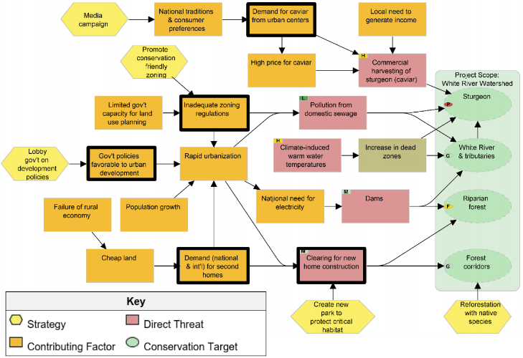**Example Situation Diagram, with key intervention points (in bold) and strategies (yellow) identified**

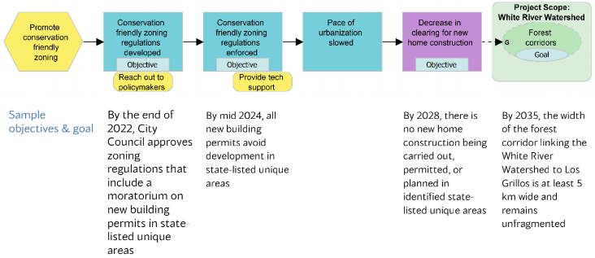**Example Results Chain (and associated objectives and goals), related to the above situation**

### Annex 2 Stakeholder/ rights holders [engagement plan](https://drive.google.com/drive/folders/1jWYVcl79XmUf5FnApmXu6QWISr-wrs79)

Summarise here the information that you gather through the project on stakeholder engagement.

This annex is mandatory for **place-based projects**, taking the following as guidance:

* See the detailed guidance [here](https://drive.google.com/drive/folders/1nGoHbsT5XilB3kuNXsgzMWMBEIYawBaA?ths=true.).
* An initial stakeholder analysis (example below) may help in developing the engagement plan
* The stakeholder engagement plan could look like the table below, but with several rows per group as you develop and understanding of the different members of each grouping (i.e. by gender, age, status, ethnicity, power etc.). Do not include personal information. Do include WWF.
* This will be a living document, modified through consultation, participation and review by partners and as the project proceeds with implementation. 

**Example - Stakeholder Analysis**

**Example –**

**Stakeholder Engagement plan**

|  |  |  |  |  |  |  |
| --- | --- | --- | --- | --- | --- | --- |
| **Stakeholder** | **Stake** | **Attitude** | **Marginalised** | **Importance** | **Role in Project** | **Type & method of engagement** |
| Dependent on resources  *The nature of their stake in the resource (e.g. livelihoods, profit, lifestyles, cultural values, etc.), and the basis of that stake (e.g. customary rights, ownership, administrative or legal responsibilities,*  *intellectual rights, social obligation, etc.)* |  | *If marginalized, note how e.g. gender, indigenous peoples, ethnic minorities, youth, disenfranchised groups* |  |  | Identify potential roles in the project cycle (planning, implementation, M&E etc)) |  |
| Types of right over resources |  |  |  |  |  |  |
| Knowledgeable about resources |  |  | *Decide who are the key stakeholders - because of claims over or dependence on the resources, or their power, authority, or responsibility* |  | Note, a particular effort may be needed to ensure the more marginalised people are engaged |  |
| Other resource interest groups eg CSOs & Gov, (partners) |  | *Define if they are: positive*  *negative*  *neutral unknown*  *Use symbols like:*  *+++, - - -, O, ?* |  |  |  |  |
| Other interest groups e.g. INGOs |  |  |  |  |  |  |
| Other groups of influence eg religious, educators, mothers, etc |  |  |  |  |  |  |

### Annex 3 Risk Management

Prepare a detailed risk assessment using the template [here](https://docs.google.com/spreadsheets/d/11UNdKLTnuVsZu8rKojhnRljYVah1Jd_o7sT5bQaGl8E/edit#gid=595520324) and the guidance [here](https://docs.google.com/document/d/17mGc-SHmx4F5bJiaAMHo4ov-fokccEfm1dtEBJWyLu0/edit#heading=h.w7ls9tlfobqa).

* A simpler version of the template is under development and is available [here](https://docs.google.com/spreadsheets/d/15nRDByEItT8uYuo-4ijYj0VwbwJFR_3pmhdop7JZu2A/edit#gid=1817364137)
* Involve specialists, experts, and senior team members to identify and assess risks.
* Provide a link to your completed risk assessment template.
* Include risks that need to be monitored in your monitoring plan.
* Keep your risk register up to date during the project to reflect emerging risks.

Note that this risk assessment process is relatively new. For further guidance or to provide feedback, contact your risk manager or office's risk champion/focal point.

### Annex 4 Monitoring Plan

Develop a monitoring plan that focuses on the project’s core information needs - to support adaptive management and assessment of the project’s effectiveness. Use either the format generated by Miradi, or the format overleaf (an Excel version is [here](https://sites.google.com/wwf.panda.org/networkstandards/policy-areas/project-and-initiative-management/2-4-guidance-by-ppms-step?authuser=0); this mirrors Part 2 of the [WWF Technical Report format](https://sites.google.com/wwf.panda.org/networkstandards/policy-areas/project-and-initiative-management/2-2-templates-concept-proposal-tpr?authuser=0)).

**Guidance on monitoring plans (**see [here](https://sites.google.com/wwf.panda.org/networkstandards/policy-areas/project-and-initiative-management/2-4-guidance-by-ppms-step?authuser=0) for detailed guidance)

1. Goals, objectives and strategies should be clearly defined before you attempt to develop indicators.
2. The number of indicators should be the “**minimum but sufficient**” required to show whether the Goals and Objectives are being achieved.
3. It is assumed that you will also monitor your **Activities** (in a simple, light way against your workplan) and your **Resources/Finances** (via your finance system).
4. Incorporate the monitoring of **Risks, assumptions, sustainability planning and safeguarding** approaches as appropriate.
5. **Operationalize your monitoring plan** and think ahead to data analysis. The required format asks for significant detail so that methods, responsibilities, budgets, use of data, and audience needs are considered up front. Plan time to regularly ‘pause and reflect’ on progress.
6. In practice, the monitoring plan may not be complete at the proposal stage but will be finalised in the early stages of implementation. Where this is the case, the **plan for completion of the monitoring plan** must be stated and included in the work plan (including baseline data collection).
7. Align with relevant **internal or external indicators** as appropriate, adding columns as necessary. For example, wider programme goals, Global Practice Outcomes and [2025 Targets](https://sites.google.com/wwf.panda.org/critical-contributions/guidance-per-practice), SDGs.
8. **Social/ poverty/ gender data / indigenous peoples** (where relevant). Where possible and appropriate, data should be disaggregated by social group. Consider also methods that allow the voices of partners and community members to be heard and recorded.

**Extract of an example monitoring plan for a Land Use Planning strategy**

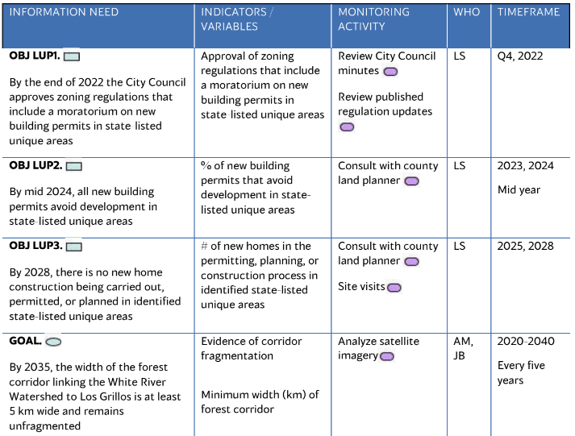

**Format for the monitoring plan**

|  |  |  |  |  |  |  |  |  |  |  |  |  |
| --- | --- | --- | --- | --- | --- | --- | --- | --- | --- | --- | --- | --- |
| **Information needs**  (from the action plan) | **Indicators**  (what will you measure?) | **Related Indicators**  (add column(s) to reference key internal or external indicators)  Please use WWF common indicators as much as possible and especially where they help demonstrate a contribution to a new global outcome or 2025 Target | **Method/ source of data**  (how will you measure?) | **Location**  (where will monitoring be done?) | **When**  (timeframe & frequency of data collection) | **Who to provide and use**  (who will provide and analyse the data?) | **Baseline data**  (most recent figure and date, or when it will be defined) | **Planned**  **intermediate result** | | | **Planned**  **final result**  (value and date) | **Cost**  (estimate for monitoring the indicator) |
| **FY** | **FY** | **FY** |
| **Goals**  Good goals are SMART and are normally linked to biodiversity or human wellbeing. |  |  |  |  | What is the status of what you are measuring at the beginning of the project/ programme? |  |  | What are the milestones you intend to reach to achieve the goal or objective? State appropriate dates for measurement. For objectives, annual measurement is recommended. Goals are likely to be measured at less frequent intervals. |  |  |  |  |
| **Objectives** |  |  |  |  |  |  |  |  |  |  |  |  |
| **Risks/ other factors**  (as necessary) |  |  |  |  |  |  |  | **N/A** | **N/A** | **N/A** | **N/A** |  |

### Annex 5 Workplan and Budget

Using the guidance below, provide a workplan and a budget.

* Normally the workplan and budget should be in detail for the first year, and at high level thereafter.
* For each year of a multi-year project, a revised (and detailed) workplan and budget is required for the upcoming year.
* There should be a clear correspondence between the main activities in the workplan and those in the budget.

**Guidance on Workplans** (detailed guidance is available [here](https://sites.google.com/wwf.panda.org/networkstandards/policy-areas/project-and-initiative-management/2-4-guidance-by-ppms-step?authuser=0), Step 3.1)

A Gantt chart format is preferred, using Miradi software or based on the format below (an Excel version is [here](https://sites.google.com/wwf.panda.org/networkstandards/policy-areas/project-and-initiative-management/2-4-guidance-by-ppms-step?authuser=0)). Other formats are equally acceptable provided they include the same parameters as below.

|  |  |  |  |  |  |  |  |
| --- | --- | --- | --- | --- | --- | --- | --- |
| **Strategy/ Activity - Description and Number.** | **Tasks/ Sub tasks** | **Who** | **When** | | | | **Cost** |
| Q1 | Q2 | Q3 | Q4 |
|  |  | Individual/ organization primarily responsible. |  |  |  |  | Estimated cost and corresponding financial account code |

**Guidance on Budgets** (detailed guidance is available [here](https://sites.google.com/wwf.panda.org/networkstandards/policy-areas/project-and-initiative-management/2-4-guidance-by-ppms-step?authuser=0) (Step 3.1) and the B3 template is [here](https://sites.google.com/wwf.panda.org/networkstandards/policy-areas/financial-management-and-administration/5-3-project-financial-management))

* Where a project is ready to proceed with implementation, provide a detailed project budget.
* The **Project Manager** is primarily responsible for developing the budget, with support from Finance colleagues.
* The Network Budget Standard, the B3 template, detailed budget template, budget checklist and Cost Recovery Standard are all available [here](https://sites.google.com/wwf.panda.org/networkstandards/policy-areas/financial-management-and-administration/5-3-project-financial-management). The standard **B3 format** must be used unless a primary donor requires an alternative format. The **detailed budget template** is recommended since it shows these activity-cost links, and it automatically rolls up the figures to the B3 format.
* Make sure the budget supports the recovery of **core costs** (see Cost Recovery above).
* Ensure that the timing of activities is realistic (e.g. factor in time for staff recruitments or completely new activities).
* Specify in-kind resources where relevant e.g. when matching funds are required.
* Once the project and budget have been approved, use the budget as a management tool: monitor progress against the budget, analyse variances, and prepare forecasts.
* Communicate any foreseen changes to donors as early as possible.

### Annex 6 Organisational/ Governance Structure (WWF and Partners)

Provide an organizational structure chart to present the organizational structure of the project, as well as any capacity assessments, due diligence assessments, agreements (MOUs, PIAs), team descriptions, job descriptions of key roles, as appropriate.

**Example: Visualization of activities of WWF and partners in a project area:**

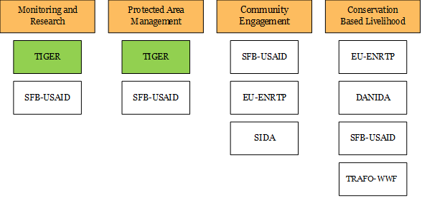

### References and Bibliography

### Sign Off (see [Approval form](https://wwforguk-my.sharepoint.com/personal/wbeale_wwf_org_uk/Documents/to%20be%20added))

1. This template is available at [www.panda.org/standards](http://www.panda.org/standards) and <https://sites.google.com/wwf.panda.org/networkstandards>.
2. This template is designed to be applicable to all mid-large projects and programmes (over €100K p.a.). For simplicity, in this document the term “project” is used throughout to mean projects, programmes and initiatives.
3. Rights-holders, from a human rights perspective, are individuals or social groups that have particular entitlements in relation to duty-bearers. Duty-bearers are state or non-state actors, that have the obligation to respect, protect, promote, and fulfil human rights of rights-holders. : this can include WWF. Being accountable to rights-holders involves giving them the opportunity to understand and influence the key decisions which are made throughout the project’s lifetime. Where Indigenous Peoples are involved, their Free, Prior and Informed Consent to all steps of the project development and implementation is essential. See the FPIC guidance. (LINK)
4. [Environmental and Social Safeguards Framework](https://sites.google.com/wwfus.org/safeguardstaskforce/home)
5. Context: the influences and events related to aparticular situation, the set of things that are happening and the conditions that exist at a particular time and place. (The context is sometimes also known as ‘the system’)
6. Also known as Direct Threats
7. Also known as Indirect Threats, Root Causes, Enabling Conditions, or Contributing Factors
8. Tools such as a [stakeholder analysis](http://www.panda.org/standards) or [political economy analysis](https://drive.google.com/file/d/1aoVrFmpOcwu9iCyhXRrniWfYSVlj3a3E/view) can help in understanding and prioritising this.
9. Goals and Objectives are also know as intended/ desired Impacts and Outcomes respectively. Goals may be long term and beyond the current phase of the project, or may be relate to a wider programme goal - yet they should be achievable in principle at least. Objectives should normally be achievable within the timeframe of the project e.g. 3-5 years.
10. Also known as Interventions
11. The level of detail included here and in Annexes 1 and 2 is a matter of judgement and will vary significantly between projects. It will often be appropriate to include only the broad strategies or major activities here in the main text and Annex 1, and provide a breakdown to smaller activities, tasks and subtasks in Annex 5.
12. A theory of change explains the underlying theory behind the project’s assumptions i.e. how the strategies will address the context in order to deliver the intended results. The [CMP Conservation Standards](https://cmp-openstandards.org/download-os/) suggest the use of Results Chains as a tool to help understand and describe your theory of change; it is helpful to also provide a supporting narrative.
13. Available on the Network Standards site [here](https://sites.google.com/wwf.panda.org/networkstandards/policy-areas/11-safeguards-essf-and-social-policies).
14. For guidance on Sustainability and Exit Strategies see [www.panda.org/standards Step 2.3](http://www.panda.org/standards%20Step%202.3)