EU NATURE LAWS FACTSHEETS
Why the Birds and Habitats Directives are vital
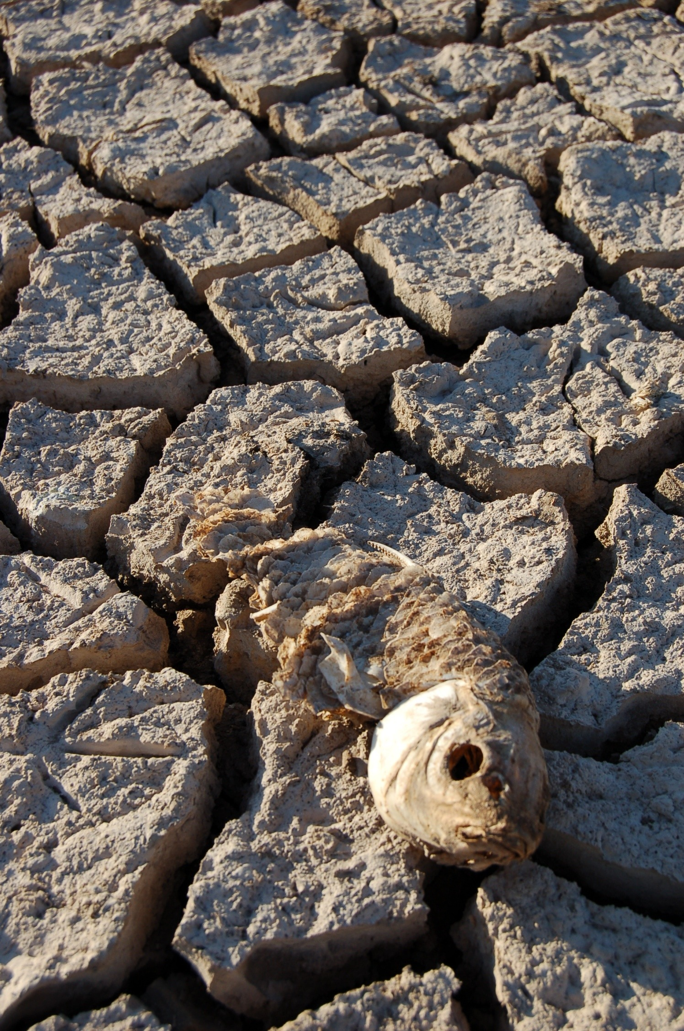  Fish backbone in dried up river bed near Coto Doñana National Park, Natura 2000 area,  Spain. (credit: WWF). | The numbers of Europe’s environmental crisis  - 60% of animals and plants of European importance and 77% of their habitats are considered to be at threat. (EEA, 2015);  - 60% of animals and plants have disappeared from Europe since 1700;  - 25% of marine mammals and 15% of terrestrial mammals, 38% of freshwater fish, 41% of freshwater molluscs, 22% of amphibians, 21% of reptiles, 16% of dragonflies, 12% of birds and 7% of butterflies are threatened with extinction at the EU level (IUCN European Red List);  - In the past 30 years we have lost over 420 million European birds. Farmland birds have fared particularly badly, with 300 million fewer birds today than in 1980;  - Grassland butterfly populations have fallen by 60% since 1990. The main driver behind this decline is thought to be changes in rural land use — primarily intensified farming and abandonment of land by farmers (EurActiv, 2014);  - One in ten wild bee species face extinction;  - Our seas are overfished, with cases like the Mediterranean where 96% or more of bottom-living fish are overfished;  - More than 40% of rivers and coastal water bodies are affected by diffuse pollution from agriculture, and only 53% of Europe’s water bodies are likely to achieve good ecological status by 2015, missing the target set by the EU Water Framework Directive (EEA 2015).
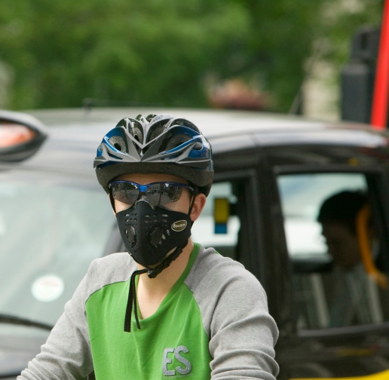  A cyclist wearing a mask to counteract air pollution, London, UK (WWF) | The socio-economic costs  - Damage from floods has cost more than €150 billion over the past 10 years, and air pollution costs around €537 billion every year (WWF report 2015)  - EU industries import every year more than €500 billion of raw materials no longer available in Europe (WWF report 2015);  - Each year Europe loses 3% of GDP due to the loss of biodiversity. That costs the EU €450 billion year after year;  - Air pollution is the number one environmental cause of death in the EU, with over 400 000 premature deaths every year (State of the Environment 2015). The external costs for this were between €330-940 billion in 2010. (EU Commission, 2012).
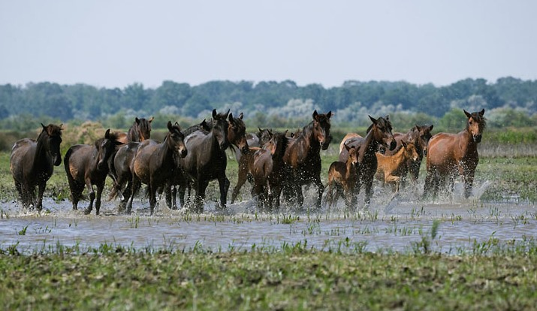  A herd of feral horses (Equus Caballus) running through shallow water in the Letea Forest, Danube Delta Biosphere Reserve, Romania, June 2009  (© naturepl.com / Kristel Richard / WWF). | Natura 2000, the world’s biggest network of protected sites  To tackle the loss of nature, Europe has put in place two important pieces of legislation, the Birds (1979) and Habitats (1992) Directives.  These laws are the cornerstones of EU nature protection policy and have brought about the creation of Natura 2000, the world’s biggest network of protected areas, covering:  - 1 million square km of land (over 18% of EU land)  - 250,000 square km of marine sites (about 4% of EU marine sites)  This means 27,000 sites and 1,000 species are under special protection.
Nature’s successes
Where properly implemented, laws have succeeded to bring positive results: some populations of rare species are recovering and the loss of valuable habitats is slowing down.
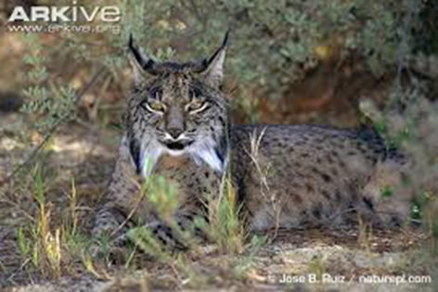  The Iberian Lynx  the world’s most endangered feline that lives only in the Iberian peninsula, has increased from 100 to about 230 animals (more info). | 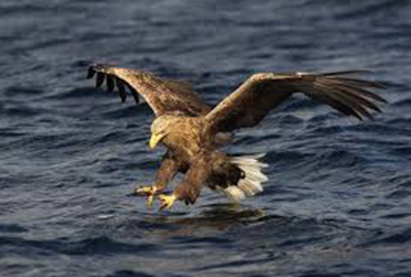  The majestic white tailed eagle that underwent dramatic declines between 1800 and 1970 and became extinct in many regions of Europe, is up to 10,000 pairs.
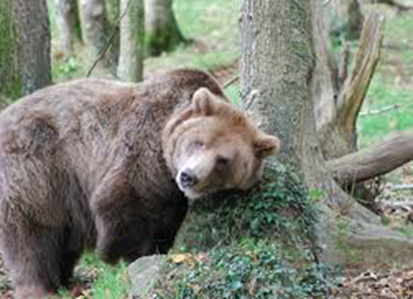  Populations of five large carnivores that had almost disappeared from Europe like the brown bear in Karelia and Spain, the wolf in Germany and Poland, the wolverine in the Scandinavian countries and the Eurasian Lynx in UK, France and Germany have doubled in population in the last ten years thanks to legal protection. | EU Nature Laws have played a crucial part in the rehabilitation of large carnivores (WWF, 2014).  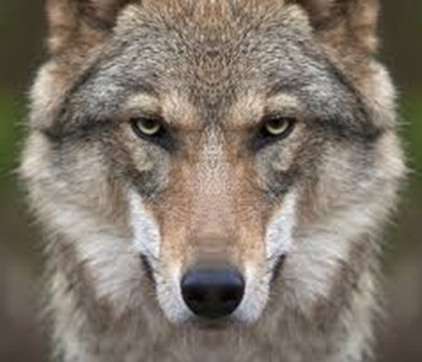
Socio-economic successes
Europe’s Nature laws do not block economic developments. Natura 2000 benefits local economies and livelihood (Financing Natura 2000, 2014 & The Economic Benefits of Natura 2000, 2012). In a Natura 2000 area all human activities are possible (farming, hunting, transport, etc) provided they are not detrimental to the species and habitats under protection. It is calculated that European environmental laws account for less than 1% of the administrative costs for businesses (Cutting Red Tape in Europe, July, 2014). The benefits delivered by Natura 2000 areas also go beyond pure economic value. Research increasingly shows mental and physical health benefits to people who regularly spend time in a natural environment.

Although EU citizens have low awareness about the specifics of the Nature Directives, Eurobarometer surveys show that 95% of EU citizens say protecting the environment is important to them personally (Eurobarometer 2014) and 77% agree that European environmental legislation is necessary for protecting the environment in their country (Eurobarometer 2014).
.  Man and his horse in a corn field. Danube River, Portile de Fier Nature Park, Romania. (© Michel Gunther / WWF-Canon)  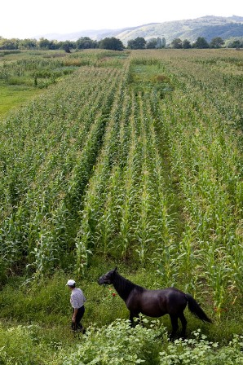  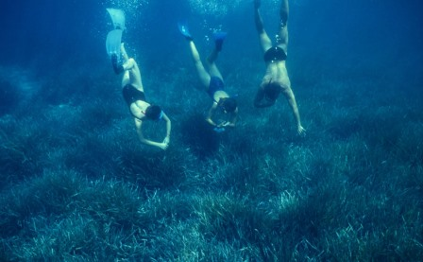  Mediterranean sea, Ile de Port-Cros, France  (© Michel Gunther / WWF-Canon) | - Ecosystem services provided by Natura 2000 and related socio-economic benefits can be valued as €200-300 billion/year, amounting to around 1.7 - 2.5% of EU GDP  (far more than 5,8 bill euro/year needed to manage the sites).  - The benefits delivered by the marine area currently protected by the network (4.7%) are worth about €1.4– 1.5 billion/year. This would increase up to €3.0–3.2 billion/year if 10% of the sea area were protected.  - Visitor spending for the Natura 2000 network was estimated at €50 to €90 billion in 2006 for 1.2 to 2.2 billion visitor days per annum, which generated an additional income of between €50 and €85 billion (Bio Intelligence Service, 2011).  - Tourism and recreation activities related to the Natura 2000 network have been estimated to support between 4.5 and 8 million FTE jobs (Bio Intelligence Service, 2011).  Wellbeing  Not all the benefits of protected sites can be quantified in economic terms. Research in 2009 into the wellbeing benefits of wildlife tourism conclude that: “The implications of this research has relevance to environmental conservation particularly the recognition that conserving habitats and wildlife has an intrinsic connection to the future well-being of the human population who are part of the ecosystem and not separate from it” (Wildlife tourism: the intangible, psychological benefits of human–wildlife encounters, Current Issues in Tourism).  Research into visits to forests and woodlands in the UK found that nature connectedness, mental well-being and sense of place were the three most important personal well-being benefits gained, and recommended that these benefits should be evenly accessed by all socio-economic groups (Well-being for all? The social distribution of benefits gained from woodlands and forests in Britain, Local Environment).  Climate  Natura 2000 sites also play an important role in mitigating and adapting to climate change (Guidance on Climate Change and Natura 2000, 2014). Natura 2000 sites currently store around 9.6 billion tonnes of carbon, equivalent to 35 billion tonnes of CO2, which is estimated to be worth between €600 and €1,130 billion (stock value in 2010).
Why we need to implement EU Nature Directives at national level

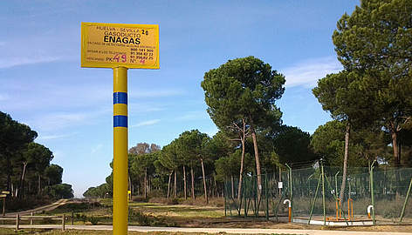  © WWF/Juanjo Carmona  Stopping damaging gas exploration in Doñana  The recent case of a gas company trying to get authorisation for big damaging gas explorations in the Natura 2000, UNESCO World Heritage Site of Coto Doñana, Spain shows why strong legal protection is needed. WWF Spain has opposed the project, denouncing irregularities in the environmental impact assessment and calling on the European Commission to intervene. The case is still open. | 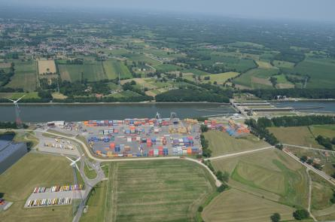  Port of Antwerp, Nature and Economy  The Port of Antwerp, Europe’s project cargo hub, includes also Natura 2000 areas. The Antwerp port area hosts 90 protected animal and plant species. The harbour received the Environmental World Ports Award 2013 in Abu Dhabi for its contribution to the environment.

Contacts:
BirdLife Europe: Luca Bonaccorsi, +32 478 20 62 84, luca.bonaccorsi@birdlife.org
WWF EPO: Stefania Campogianni,+32 499 53 97 36, scampogianni@wwf.eu
European Environmental Bureau: Philippa Jones, +32 471 57 01 81, philippa.jones@eeb.org
Friends of the Earth Europe: Paul Hallows, + 32 2 839 10 33, paul.hallows@foeeurope.org.

